  ANALYSIS OF THE DEMAND AND SUPPLY NEEDS OF A FMCG NOODLES COMPANY | Objective  Using historical data to determine an optimum weight of the product to be shipped each time to the warehouse by analyzing the demand pattern in different pockets of the country so management can drive the advertisement campaign particular in those pockets.  Orhine Adidi  Data Analyst

Table of Contents
TABLE OF FIGURES 2
INTRODUCTION 3
EXECUTIVE SUMMARY 3
BUSINESS PROBLEM / PROBLEM STATEMENT 5
AIM/GOAL 5
OBJECTIVE 5
DATA DESCRIPTION 5
DATA PREPARATION / CLEANING 6
METHODOLOGY 7
KEY FINDINGS/INSIGHTS 7
KEY PERFORMANCE INDICATORS 8
EXPLORATORY DATA ANALYSIS VISUALIZATIONS 8
STATISTICAL ANALYSIS 13
Correlation Heatmap 13
REGRESSION ANALYSIS 15
CONCLUSIONS 20
RECOMMENDATIONS 21
LIMITATIONS 23
APPENDIX 24
REFERENCES 25

TABLE OF FIGURES
Fig 1 Warehouse Distribution and Avg Product ton by Capacity Size 8
Fig 2 Warehouse Distribution and Avg Product ton by Location 9
Fig 3 Warehouse Distribution by Zone 9
Fig 4 Average Product ton delivered by Zone 10
Fig 5 Warehouse Distribution by Regional Zone 10
Fig 6 Average Product ton delivered by Regional Zone 11
Fig 7 Warehouse Distribution and Avg Product ton by Owner Type 11
Fig 8 Warehouse Distribution by Government Certificate 12
Fig 9 Average Product ton distribution by Government Certificate 12
Fig 10 Correlation Heatmap Between Numerical Variables in Dataset 13
Fig 11 Regression Model Using all Numerical Variables 15
Fig 12 Regression Model (Formula) 16
Fig 13 Three different Predictions from Model 1 17
Fig 14 Regression Model Using only Significant Variables from Correlation Heatmap 18
Fig 15 Regression Model 2 19
Fig 16 Three different predictions from Model 2 19
Fig 17 Excel Dashboard Showing Overview of Adine Noodles Dataset 24

INTRODUCTION
Adine Noodles is a fast-growing FMCG company in the instant noodles company with over two years experience in Noodle supply spread over various states in Africa is seeking to understand their data better due to rising competitions in the market, lapses in revenue and profit, location sale issues. They hired The A Company to perform an analysis on their data to dive into the data and bring out useful information and recommendation to help them stay in the market and grow in the industry.

EXECUTIVE SUMMARY
Adine Noodles commissioned this analysis to address increasing competition, revenue and profit pressures, and a clear mismatch between product demand and supply across its warehouse network. The primary objective was to develop a data-driven model capable of optimizing the weight of products shipped to each warehouse in order to reduce inventory losses and improve operational efficiency.
The analysis, conducted on 25,000 warehouse records using cleaned and structured historical data, reveals that Adine Noodles operates a predominantly rural distribution network (over 91%), with the highest warehouse concentration in the Northern region. Despite significant variation in the number and size of warehouses across zones, the average product ton delivered remains largely consistent (22,000 tons) across warehouse sizes and regions.
Importantly, findings show that warehouse quantity does not determine delivery volume; instead, capacity size and operational conditions have greater influence. Additionally, refill requests (demand proxy) show almost no statistical relationship with product weight delivered, confirming management’s concern that supply decisions are not currently aligned with demand patterns.
Critical Drivers of Product Delivery
From correlation and regression analysis (R² = 0.97), four operational variables significantly influence product weight delivered:
- Transport Issues (Negative Impact)
- Storage Issues (Strong Positive Impact)
- Temperature-Regulated Machinery (Positive Impact)
- Warehouse Breakdowns (Negative Impact)
Other factors—including demand (refill requests), competition levels, retail shop count, number of distributors, government checks, and warehouse distance from hubs—were found to have negligible impact on delivery weight.
Predictive Optimization Model
The following regression model was developed to forecast optimal product shipment weight:
y = (-300.25X₁) + (1257.32X₂) + (943.82X₃) - (228.04X₄) + 1304.36
Where:
- X₁ = Transport Issues
- X₂ = Storage Issues
- X₃ = Temperature-Regulated Machines
- X₄ = Warehouse Breakdowns
With an R² of 0.97, the model explains 97% of the variability in delivery weight and is suitable for operational forecasting and decision-making.
The findings indicate that Adine Noodles’ supply decisions are currently driven more by operational disruptions and infrastructure conditions than by actual demand signals. This misalignment is likely contributing to excess inventory in low-demand areas and shortages in high-demand areas.
To optimize performance and profitability, management should prioritize:
- Reducing transport disruptions through preventive fleet maintenance and route optimization.
- Investigating and correcting root causes of storage issues, especially overstocking and inventory mismanagement.
- Strategically expanding temperature-regulated infrastructure in high-demand or high-capacity zones.
- Improving warehouse reliability through preventive maintenance and backup systems.
- Integrating the predictive model into planning dashboards for scenario simulation, weekly forecasting, and operational target setting.

BUSINESS PROBLEM / PROBLEM STATEMENT
Adine Noodles (A FMCG company) has entered into the instant noodles business two years back. Their higher management has notices that there is a miss match in the demand and supply. Where the demand is high, supply is pretty low and where the demand is low, supply is pretty high. In both the ways it is an inventory cost loss to the company; hence, the higher management wants to optimize the supply quantity in each and every warehouse in entire country.

AIM/GOAL
The main aim of this analysis is to build a model, using historical data that will determine an optimum weight of the product to be shipped each time to the warehouse.

OBJECTIVE
- Analyze the demand pattern in different pockets of the country.
- How much product is supplied vs demanded per warehouse/region/zones?
- Analyze warehouse issues (transport, breakdowns, electricity, floods etc.)
- Recommendations to drive advertisement campaigns in country pockets.

DATA DESCRIPTION
The dataset used for this analysis was obtained from Kaggle (https://www.kaggle.com/datasets/suraj9727/supply-chain-optimization-for-a-fmcg-company) and contains 25,000 sales records for 2 years (years not specified).
Key variables include in the dataset:
Variable | Business Description
Ware_house_ID | Unique identifiers for each warehouse.
WH_Manager_ID | Unique identifiers for the warehouse managers.
Location_type | Indicates the type of location where each warehouse is situated.
WH_capacity_size | Represents the capacity or size of each warehouse.
zone | Categorizes the warehouses into specific zones.
WH_regional_zone | Assigns each warehouse to a regional zone.
num_refill_req_l3m | Records the number of refill requests received in the last 3 months.
transport_issue_l1y | Indicates the occurrence of any transport-related issues within the last year.
Competitor_in_mkt | Specifies the presence of competitors in the market.
retail_shop_num | Provides the number of retail shops associated with each warehouse.
wh_owner_type | Describes the ownership type of each warehouse.
distributor_num | Represents the number of distributors associated with each warehouse.
flood_impacted | Indicates whether a warehouse has been impacted by floods.
flood_proof | Specifies whether a warehouse is flood-proof.
electric_supply | Indicates the status of electric supply to each warehouse.
dist_from_hub | Represents the distance of each warehouse from the hub.
workers_num | Provides the number of workers employed at each warehouse.
wh_est_year | Represents the year in which each warehouse was established.
storage_issue_reported_l3m | Indicates whether any storage issues have been reported in the last 3 months.
temp_reg_mach | Specifies the presence of temperature regulation machinery at each warehouse.
approved_wh_govt_certificate | Indicates if each warehouse has an approved government certificate.
wh_breakdown_l3m | Indicates whether any breakdowns have occurred at each warehouse in the last 3 months.
govt_check_l3m | Indicates if government checks have been conducted for each warehouse in the last 3 months.
product_wg_ton | Represents the weight of the product in tons.

DATA PREPARATION / CLEANING
Dataset initially had 24 columns by 25,000 rows. Cleaning involved;
- Removing duplicate records.
- Converting all numerical columns to numeric values.
- Missing values replacement: I replaced the missing values on the workers_num column with average of the column, the volume of missing data there wasn’t much – hence that was the best option as it couldn’t be gotten from the source.
- Feature Engineering: I created new columns to convert 0s and 1s to No and Yes on the flood and electric issue columns.
- Trimming for white spaces.
- Formatting of text columns in terms of letter casing and
- Spell checking.
Overall, the dataset was clean and major errors were found. After cleaning the dataset still had 24 columns by 25,000 rows.

METHODOLOGY
Analysis was conducted using Microsoft Excel. Pivot tables were used to summarize warehouse distribution and average product ton delivered by zone, location, regional zone, capacity size, owner type and government certificate. Descriptive statistics such average were calculated on overall average product ton, average num_refill_req, average workers_num, average dist_from_hub, average retail_shop_num, average transport issue. Correlations were also analyzed to evaluate the relationship between all major variables and product ton delivered.

KEY FINDINGS/INSIGHTS
Adine Noodles has over 25,000 companies with 1 manager per warehouse, out of which 54.31% of those companies are company owned and 45.69% are rented. By zone distribution, there are more warehouses in the North (over 10K), followed by West (7.93K) and less of them in the East (just over 400), out of which in the regional zone, zone 6 (8.34K) has more warehouses, followed by zone 5 (4.59K), zone 1 has fewer warehouses (2.05K).
There are also more large warehouses (10.17K) than Mid (10.02K) and Small (4.81K). By government certificate, there are more warehouses with C certificates (5.5K) than others. The company has more warehouses in rural areas (over 91.83%) than urban areas.
On average all zones in the country have a demand (refill request) of approximately 4 requests and an overall average supply (product delivered) of 22,000 (ton) of products delivered.
The average transport issue across the country is approximately 1 (0.77), indicating that most zones/warehouses have little to no recorded transport issues.

KEY PERFORMANCE INDICATORS
- Total number of warehouses – 25,000
- Total number of managers – 25,000
- Average Product ton delivered – 22,000
- Average number of refill request – 4.09
- Average workers number – 28.95
- Average distance from warehouse – 163.54 Km
- Average distributors number – 42.42
- Average retail shop number – 5,000
- Average zone count – 4
- Average location count – 2
- Average transport issue – 0.77

EXPLORATORY DATA ANALYSIS VISUALIZATIONS

Fig 1 Warehouse Distribution and Avg Product ton by Capacity Size
Figure 1 shows the warehouse distribution across different warehouse sizes in the country. It can be observed that although the number of type of warehouses differ, especially when comparing Small (4.81K) warehouses to Mid (10.02K) and Large (10.17K) houses, in terms of average product (in ton) delivered, there are all approximately the same - they all get an average of 22,000 products delivered regardless of size.

Fig 2 Warehouse Distribution and Avg Product ton by Location
Figure 2 shows the warehouse distribution across Rural and Urban locations in the country. Although they are more warehouses in the Rural area (91.83%) of the country, on average more products get delivered to the Urban area (25K) than Rural areas.

Fig 3 Warehouse Distribution by Zone
Figure 3 shows the warehouse distribution by Regional Zone. We can see that the North zone has more warehouses. Before now we also saw that most warehouses are in Rural areas, going deeper we see that overall, regardless of zone the countries warehouses are situated in the Rural areas of these zones. North having more warehouses (10.28K) and East having the least (429).

Fig 4 Average Product ton delivered by Zone
Figure 4 shows the average weight of product delivered by zone. We see that more East zone has the highest average product weight delivered. Relating this to the number of warehouses per zone, where we observed that East zone has fewer warehouses, this signifies that number of warehouses don’t determine the average weight of products being delivered to that zone, but rather the capacity size of those warehouses.

Fig 5 Warehouse Distribution by Regional Zone
Figure 5 shows the warehouse distribution by Regional Zone. Each Region from East, West, North and South is divided into 6 zones (Zone 1-6). The chart shows us the overall distribution of warehouses per zone. Zone 6 being the one with the highest number of warehouses.

Fig 6 Average Product ton delivered by Regional Zone
Figure 6 shows the average weight of product delivered to each regional zone. We observe the same thing as before – that is the weight of products being delivered isn’t about the number of warehouses in that zone, but rather the capacity size of the warehouses in those zones. Here Zone 2 has the highest average weight of product delivered to it, whereas zone 6 has more warehouses overall.

Fig 7 Warehouse Distribution and Avg Product ton by Owner Type
Figure 7 shows the warehouse distribution by owner type, We see that Adine Noodles more Company owned (54.31%) warehouses than Rented (45.69%). But in terms of average product ton delivered, the average weight of products delivered is almost the same on company owned (22.04K) and Rented (22.18K) warehouses.

Fig 8 Warehouse Distribution by Government Certificate
Figure 8 shows the warehouse distribution by warehouse that have gone through government checks in the last 3 months. We see that we have more warehouses operating under C certificates (5.5K) and a few of them (NA - 908) whose certification isn’t recorded yet.

Fig 9 Average Product ton distribution by Government Certificate
Figure 9 shows the average weight of product delivered to warehouses based on their government certificate, we see that warehouses with highest issues certificate – A+ also has the highest average weight of product being delivered. Also, we observe it all through – that the higher the government certificate the higher the average weight of product being delivered.

STATISTICAL ANALYSIS

Correlation Heatmap
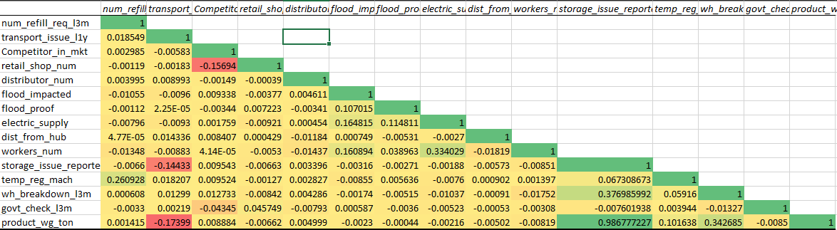
Fig 10 Correlation Heatmap Between Numerical Variables in Dataset
Figure 10 shows how all numerical variables from the Adine Noodles dataset are affecting each other. Since the variable of focus is Product weight, all detailed explanations will be directed towards other variable relation with product weight, which will in turn be used to build the model to optimize weight of product delivered.
From the correlation heatmap, we can see that;
- Number of refill request which represents demand, has a negligible relationship with product ton (0.001415) – indicating that it doesn’t actually have an effect on the supply (weight of product delivered)
- Number of transport issues reported within the last 3 months has a weak negative relationship with product ton (-0.17399) – indicating that the more transport issues are reported they is a tendency for the product ton delivered to reduce and vice versa.
- Competitors has an almost negligible relationship with product ton (0.008884) – indicating that warehouse competition doesn’t actually have an effect on the supply (weight of product delivered).
- Retail shop number has a negative but negligible relationship with product ton (-0.00662) – indicating that the number of retail shop connected to the warehouses doesn’t actually have an effect on the supply (weight of product delivered).
- Number of distributors has a negligible relationship with product ton (0.004499) – indicating that number of distributors doesn’t actually have an effect on the supply (weight of product delivered).
- Flood impact notice, Flood proof, electric supply warehouses all have negative but negligible relationship with product ton – indicating that the number of regardless of whether a warehouse was flooded or has flood proof or has electric supply they also don’t actually have an effect on the supply (weight of product delivered).
- Distance from hub and number of workers also has a negative but negligible relationship with product ton – indicating that they both don’t actually have an effect on the supply (weight of product delivered).
- Storage issue reported has a strong positive relationship (0.9867) with product ton – indicating that the more storage issues are reported possibly due to over stocking or products going bad from poor storage, the tendency for more products to be shipped to those warehouses.
- Temperature regulation has a weak positive relationship with product ton (0.1016) – indicating that the more warehouses use temperature regulation, the slight tendency for more products to be delivered.
- Warehouse breakdown has a moderate positive relationship with product ton (0.3426) – indicating that as warehouses report more breakdowns, possibly due to their storage issues, they tend to have more products delivered to them.
- Government checks has a negative and negligible relationship with product ton (-0.0085) – indicating that government checks doesn’t actually have an effect on the supply (weight of product delivered). We cant check based on certificates given due to it being a text variable.

REGRESSION ANALYSIS
Based on the aim of the project to build a model to optimize for delivery of product based on weight, two regression models were built to solve this problem.
The first model takes into consideration all numerical variables into predicting product weight. While, the second model takes into consideration just the significant variables in terms of correlation (0.1 and above) with product weight.
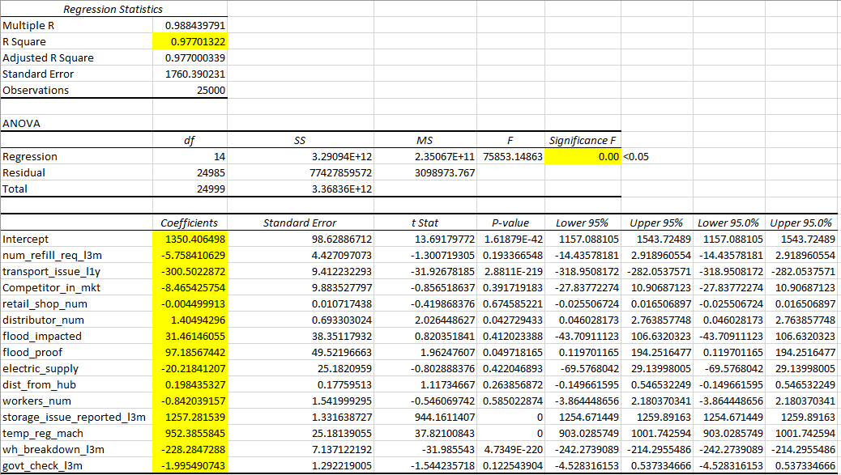
Fig 11 Regression Model Using all Numerical Variables
Figure 11 shows the regression summary built using all original numerical variables from the dataset. Based on a Margin of Error of 0.05, we see that our significance level is less than that, so our model is suitable for prediction. R-Squared – 0.97, indicates our 97% variability of our model prediction can be explained by the variables that was used to build it.
Here we observe the same effects as we did with the correlation heatmap – refill request(demand), transport issue, number of competitors, number of retail shops, electric supply, number of workers, warehouse breakdown, government check all have a negative impact on product weight. Whereas number of distributors, flood impact, flood proof, distance from hub, storage issues, temperature regulation, all impact product weight positively. Storage issues being the variable with the highest level of impact.
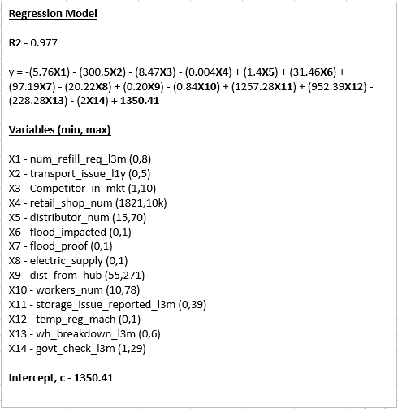
Fig 12 Regression Model (Formula)
Figure 12 shows the regression model gotten from the regression summary, the placing of the coefficient of each variable into the model. The minimum and maximum of each variable are noted, which will be used for prediction.
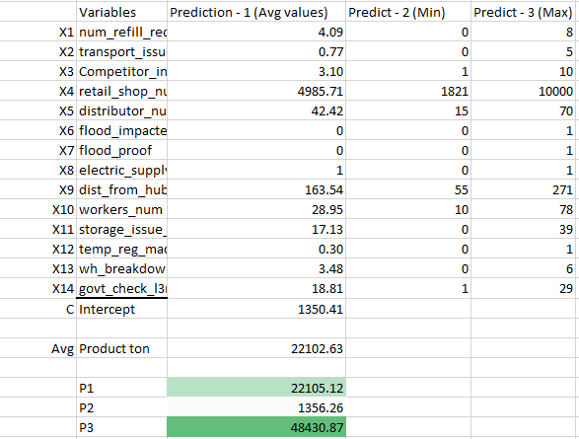
Fig 13 Three different Predictions from Model 1
Figure 13 shows the prediction gotten from the model.
- P1 (Prediction 1) was gotten using the average value of each variable to predict the product weight. We see that after using the average of each variable, the product weight predicted (~22K ton) is similar to the actual average product weight (~22K ton) of the data.
- P2 (Prediction 2) was gotten using the minimum value of each variable. We see that when number of refill requests is 0, 0 transport issues, minimum of 1 competitor, minimum of 1821 retail shops and so on for other variables as seen in figure 13, the product weight predicted (~1356 ton) is very close to the intercept (1350 ton).
- P3 (Prediction 3) was gotten using the maximum value of each variable. We see that when maximum number of refill requests which is 8, 5 transport issues, maximum of 10 competitors, maximum of 10000 retail shops and so on for other variables as seen in figure 13, the product weight predicted (~48K ton) is on the high level.
This model can be used when considering all variables in order to optimize for the best possible product weight to deliver given the change in these variables.
But as we saw on the correlation heatmap, not all variables have significance in terms of affecting product weight, hence a second model was built for prediction.
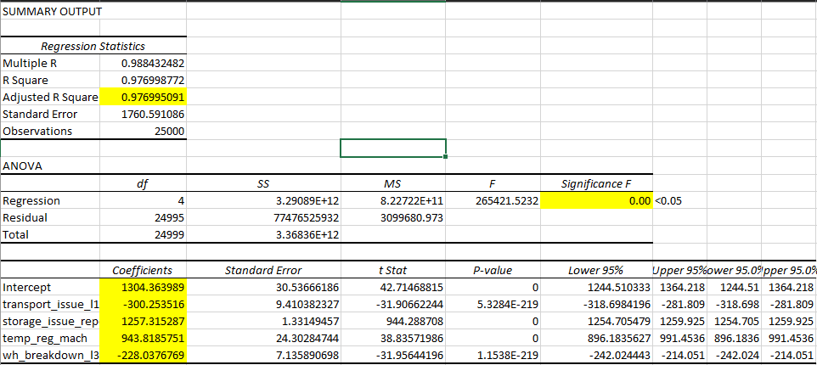
Fig 14 Regression Model Using only Significant Variables from Correlation Heatmap
Figure 14 shows the regression summary built using only relevant numerical variables in terms of correlation (0.1 and above) with product ton. Based on a Margin of Error of 0.05, we see that our significance level is less than that, so our model is suitable for prediction. R-Squared – 0.97, indicates our 97% variability of our model prediction can be explained by the variables that was used to build it. This R-Squared is the same as the first model which involved all variables – this indicates that those variables that were left out in this model are truly not relevant in prediction.
Here we observe the same effects as we did with the correlation heatmap – transport issue, warehouse breakdown, both have a negative impact on product weight. Whereas storage issues and temperature regulation both impact product weight positively. Storage issues being the variable with the highest level of impact.

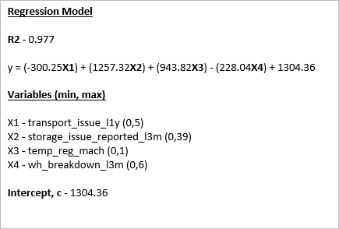
Fig 15 Regression Model 2
Figure 15 shows the regression model gotten from the regression summary, the placing of the coefficient of each variable into the model. The minimum and maximum of each variable are noted, which will be used for prediction.
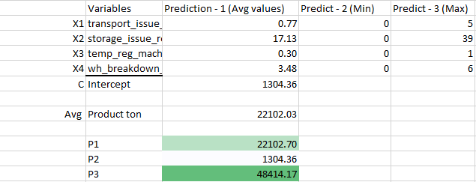
Fig 16 Three different predictions from Model 2
Figure 16 shows the prediction gotten from model 2.
- P1 (Prediction 1) was gotten using the average value of each variable to predict the product weight. We see that after using the average of each variable, the product weight predicted (~22K ton) is very similar to the actual average product weight (~22K ton) of the data – even closer than model 1.
- P2 (Prediction 2) was gotten using the minimum value of each variable. For this model, the minimum value of the variables are all 0, hence the predicted product ton is equal to the intercept of the model.
- P3 (Prediction 3) was gotten using the maximum value of each variable. We see that the product weight predicted (~48K ton) is on the high level – which is similar to model 1.
This model seems better than model 1, because of the focus on key variables to predict product ton and from this we see that the accuracy is even better than model 1.

CONCLUSIONS
In conclusion, from the correlation heatmap and from the predictive model, we see that the only variables that have a significant impact on product weight to be delivered are:
- Number of transport issues reported – which for every increase in transport issues, the product weight delivered is reduced. Meaning, if possibly there is vehicle breakdown or road blockage, this may lead to loosing of products.
- Number of storage issues reported – which for every increase in storage issues, the product weight delivered is increased. Possible meaning that when storage issues are reported, instead of more products (Quantity) to be delivered, only heavier shipments are delivered.
- Temperature regulated machineries – which for every increase, the product weight delivered is increased. Possible meaning that, the more warehouses have temperature regulated machines, the more products get delivered there – possibly more frozen goods.
- Warehouse breakdowns – which for every reported warehouse breakdown, the product weight delivered is reduced. Meaning, for every reported warehouse breakdown, less products will be delivered there due to the breakdown.
- Model to be used to optimize for future deliveries with an R-Square of 0.97 is:
y = (-300.25X$1$) + (1257.32 X$2$) + (943.82 X$3$) - (228.04 X$4$) + 1304.36
where,
y = product weight
X$1$ = number of transport issues
X$2$ = storage issues reported
X$3$ = temperature regulated machines
X$4$ = warehouse breakdown

RECOMMENDATIONS
- Reduce Transport Issues (Highest Operational Risk)
Impact: Every 1 additional transport issue: ~300ton reduction in delivered product weight.
Transport issues can be reduced by scheduling maintenance on vehicles to prevent breakdowns. By enabling real time monitoring using GPS tracking to spot areas of traffic and following back up routes.
- Investigate Storage Issues (Positive but Risky Signal)
Impact: Every 1 additional storage issue: ~1,257ton increase in delivered weight.
This suggests:
- Heavier shipments are prioritized when storage problems occur
- Or inventory reallocation happens when issues are reported
Storage issues have a positive impact on higher delivery but actionable steps will involves conducting root cause analysis on why – issues like inventory mismanagement, capacity overflow, misalignment between demand and inflow. Introducing a warehouse management system can also help to be able to track effectively products causing the storage issues.
- Increase Temperature-Regulated Machinery (Growth Lever)
Impact: Every 1 additional machine → ~944ton increase in delivered weight.
This is a clear investment opportunity into more machines.
Actionable steps involve, adding temperature-controlled units in:
- High-demand regions
- Perishable goods hubs
Focus on warehouses with:
- High turnover and in strategic locations

- Reduce Warehouse Breakdowns (Stability Factor)
Impact: Every 1 breakdown: ~228ton reduction in delivered weight.
Less severe than transport issues, but still harmful. Actionable steps involve,
Preventive Facility Maintenance by scheduling electrical system checks, cooling system inspections, structural audits. Use of backup generators.
- Use the Predictive Model for Operational Planning
With R² = 0.97, this model is highly reliable.
Practical Applications:
A. Scenario Planning
Before increasing capacity:
Simulate:
  - What if transport issues increase by 2?
  - What if we add 3 temperature machines?
Predict delivery outcomes before investing.
B. Weekly Performance Dashboard
Use the equation to:
- Forecast expected delivery weight
- Compare predicted vs actual
C. Set Operational Targets
Example:
- Transport issues must remain below X to maintain target weight
- Warehouse breakdowns must not exceed Y

Strategic Priority Ranking (Based on Coefficient Magnitude & Risk)
Rank | Focus Area | Action
1 | Transport Issues | Aggressively reduce
2 | Temperature Machinery | Invest and expand
3 | Warehouse Breakdowns | Improve maintenance
4 | Storage Issues | Investigate & optimize

LIMITATIONS
A limitation from this analysis is due to Excel being the tool of use. Due to these non-numerical variables like warehouse, zone, manager, location etc weren’t involved in building the predictive model. So, this can be analyzed better with python as the tool taken into consideration those variables.

APPENDIX
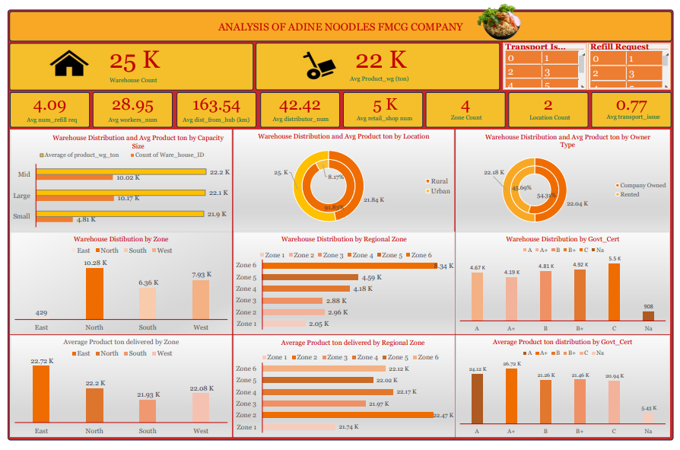
Fig 17 Excel Dashboard Showing Overview of Adine Noodles Dataset

REFERENCES
Cover Page Photo by Jeff Siepman on Unsplash
Dashboard noodles Photo by ikhsan baihaqi on Unsplash

